## 

## Introduction

In today's digital age, data has become a valuable asset for individuals and businesses alike. With the rise of artificial intelligence (AI) and machine learning, the potential for data monetization has never been greater. At hushh, we believe that your data should be your business, and we're dedicated to helping you unlock its full potential. In this blog post, we'll explore the world of data monetization and how our platform empowers you to take control of your personal data.



## What is Data Monetization?

Data monetization is the process of converting your personal data into a financial asset. This can be achieved through various means, such as selling your data to third-party companies, using it to improve your own products and services, or leveraging it to gain insights that drive business decisions. The key to successful data monetization is understanding the value of your data and how to extract that value in a way that benefits you.

## Benefits of Data Monetization

Data monetization offers several benefits for data providers, and also for the wider technological landscape in terms of incentivizing innovation.

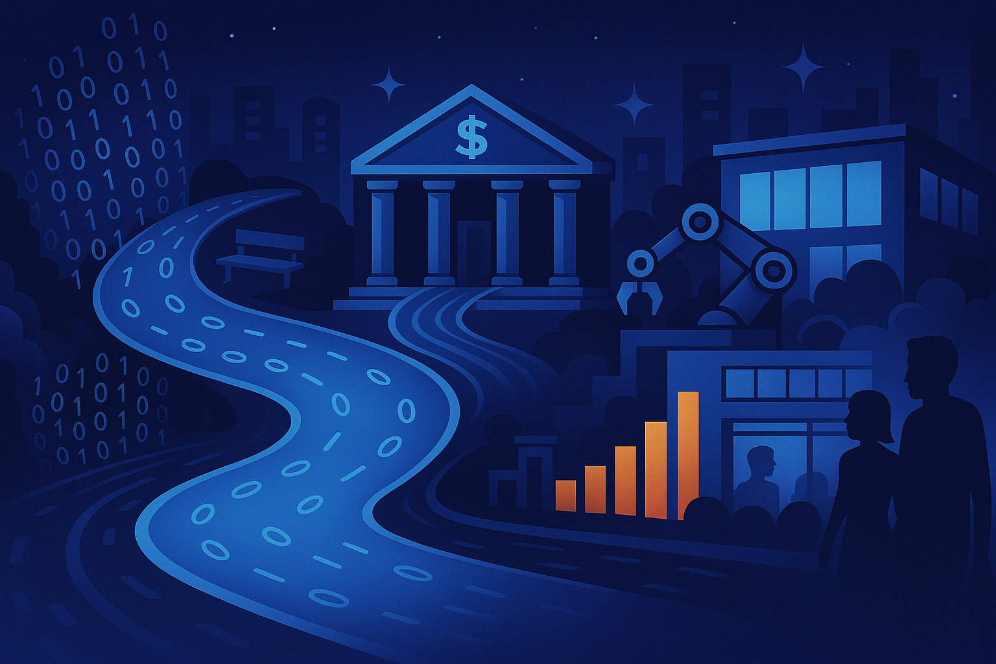

### Generate Net-New Revenue

The most attractive part of data monetization is that it allows you to generate a new stream of revenue. This benefit is even more promising if you're capitalizing on your existing data assets. Monetizing data gives enables you to extract revenue from assets which would otherwise lie dormant.

### Audit Existing Data Government

Data monetization entails auditing your existing data government processes. So it can also shed light on company's internal data usage. This helps you improve overall data management practices within your organization, with a view to optimizing your data offerings to then sell them.

### Supports Economic and AI Innovation

Lastly, data monetization contributes to a healthy business and technology landscape. With more data available, more innovation and AI development can take place. It also levels the economic playing field. If every company has valuable data to sell, small fish companies can disrupt the companies which overpower them in terms of other capital.

## Challenges Associated with Data Monetization

Data monetization, while beneficial, comes with its share of challenges for data providers.



### Privacy Concerns

Firstly, there are privacy and regulatory concerns, such as compliance with data protection laws like GDPR or HIPAA, which require careful handling of customer data.

### Maintaining Data Quality

Additionally, ensuring data quality and accuracy is a constant challenge, as inaccuracies can erode trust and reputation.

### Retaining Competitive Edge

Lastly, competition in the data market is fierce and ever-growing as data monetization goes mainstream. Data providers must continually innovate to stay ahead.

## How to Prepare for Data Monetization

To prepare for data monetization, follow these four steps:

* Gain Buy-in Gain buy-in from stakeholders and ensure that everyone is aligned with the goals and objectives of data monetization.
* Assess Existing Data and Determine Future Collection Assess your existing data and determine what data you need to collect in the future to achieve your goals.
* Decide Your Audience Decide who your target audience is and what kind of data they need to achieve their goals.
* Establish a Data Monetization Strategy Establish a data monetization strategy that outlines how you will collect, analyze, and monetize your data.

## Data Monetization methods

Though there are multiple ways to talk about data monetization, let’s take a look at the ways in which data analytics are useful. We have spoken about the broad use cases above where data analytics can be leveraged, but now let’s take a different perspective, and look at it from an organizational level.

But before we go into the methods of data monetization, let’s take a look at how data analytics would be beneficial in terms of monetization. You might have seen this before or have heard of Analytics [maturity stages by Kearney](https://www.hushh.ai/blogs/'https://www.kearney.com/service/digital-analytics/article/-/insights/the-untapped-value-of-analytics'). The four stages include Laggards, Followers, Explorers, and Leaders. This analysis talks about how laggards experience 60% lesser profits than leaders, and only once you reach the explorers' stage can you see the true value of analytics.

So the next time you think about whether data analytics would be beneficial or not, or if you are not seeing results immediately think about which position you would have in the analytics maturity assessment, and how data analytics would be beneficial for your organization.

### Insights as a service

This is about breaking down the data to the insight level i.e. transforming, analyzing, and drilling the data down to an insight level that can be shared with the business stakeholders or end users. This can be taken in a one-time or subscription format. Some of the examples include how companies like Meta or review platforms take subscriptions for insights about how customers interact with their platforms. This can help marketing or sales understand how to reach customers better. This can also be the creation of insights from the internal data by using data analytics or machine learning techniques.

### Embedded Analytics

Though this can also be a part of Insights, it is important to note that with [Embedded analytics](https://www.hushh.ai/blogs/'https://www.polestarllp.com/blog/embedded-analytics-drive-user-adoption') you bring insights to existing workflows or existing applications by embedding visualizations or new dashboards in them. This is extremely useful when people are concerned with change management as one of the barriers i.e. change in the workflows or the need for learning new technologies as part of getting insights.

### Data as a service

The most direct form of data analytics is data as a service. Not to be confused with Data analytics as a service, Data-as-a-service is all about selling data to consumers or intermediaries. The data can be in the form of raw data or congregated form. The data being sold can be without any insights or just graded data. For example, any data you gather from multiple sources by grading them about specific vendors, etc. also falls under this category. Such data can be shared via APIs, under online marketplaces, or direct data dumps.

## Use cases of Data Monetization

Data Analytics & Data monetization has become a differentiator for most companies to help them understand and access newer sources of revenue. Though most organizations understand it, the concept is fairly new, according to a [report by Mckinsey](https://www.hushh.ai/blogs/'https://www.mckinsey.com/capabilities/quantumblack/our-insights/fueling-growth-through-data-monetization'), “41 percent of respondents whose companies have begun to monetize data, a majority say they began doing so just in the past two years”

Some of the industries in which data monetization is rather prevalent now are materials and energy, financial services, and high-tech. The respondents at the high-performing companies which have implemented data monetization see a top-line benefit i.e. they are 3x more likely than others to say that their data monetization efforts contribute more than 20 percent to company revenues.

### Barriers to Data Monetization

Now that we know of the multiple methods and the multiple benefits of data monetization let us also understand what the current barriers are:

* Adoption of the right technologies that are suitable and relevant for your organization
* Lack of understanding of what the customer needs
* Absence of delivering accurate information on a timely basis
* Lack of quality data in a secure way
* Acquiring diverse data but unsure of the use
* Accessing data in siloes

## Conclusion

Data monetization is a powerful tool that can help you unlock the full potential of your personal data. At hushh, we're committed to providing you with the tools and services necessary to take control of your data and turn it into a financial asset. By leveraging our platform, you can generate a new stream of revenue, audit your existing data government, and support economic and AI innovation. Join the hushh community today and start monetizing your data like never before!